Requirements Document

1 Introduction

Sometimes when you leave your home, you may ask yourself: “Have I closed the door? Have I switched my iron off?” The aim of this project is to solve this problem. The main features are door state control and iron connection state control through the web-browser. So the name of this project is “Unmindful house”.

2 User Requirements

2.1 Software Interfaces

The product will interact with the web-browser such as Chrome, Mozilla, Internet Explorer etc.

2.2 User Interfaces

User will interact with the system through the html page.

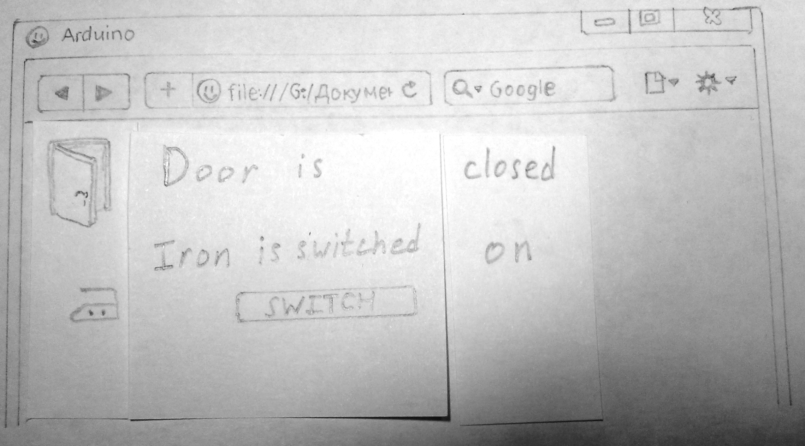

Pic.1

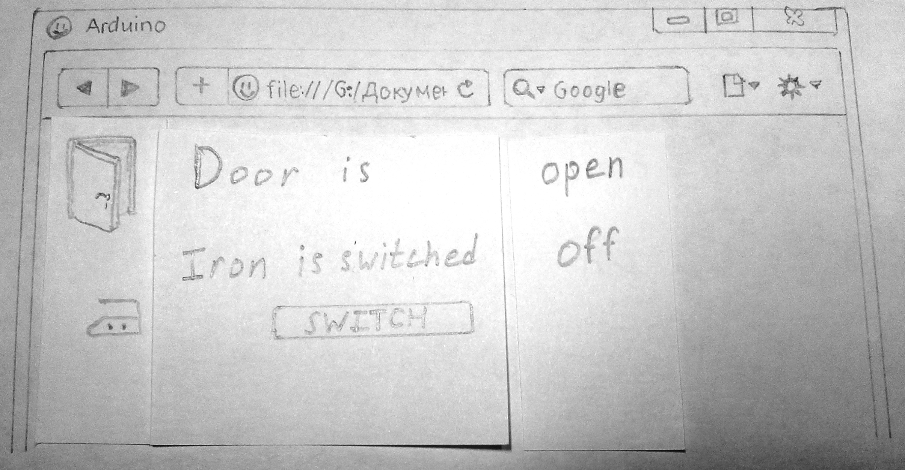

Pic.2

2.3 User Characteristics

The product is aimed at people with basic computer skills. For setting up the system the qualified in IT stuff is required.

2.4 Assumptions and Dependencies

The factors that may affect the requirements stated in the document are:

- availability of the components of the system;

-requirements of the project manager.

3 System Requirements

3.1 Functional Requirements

1. The user must have an access to the control panel of the system (pic.1 & 2) via web-browser;

2. The system must determine the state of the door: if the door is open there will be an inscription: “Door is open” in browser. If the door is closed the user will be able to see an inscription: “Door is closed”;

3. The system must determine the state of the load: if the load, e.g. iron, is switched on, the user will see an inscription: “Iron is switched on” in browser;

4. The user must be able to switch the load off after clicking on the button “Switch”.

3.2 Non-Functional Requirements

3.2.1 SOFTWARE QUALITY ATTRIBUTES

1. The project must be based on ARDUINO platform;

2. The system should connect to the network via Ethernet;

3. The switching of the controlled load must be realized on relay;

4. Door state control must be realized on limit switch;

5. Load state must be controlled by current measurement.

The system must be:

-reliable;

-safe;

-compact.

Access to the system must be carried out over HTTP.

Reliability is very important, because the system fault can cause fire if the heating element is switched on. Reliability is determined by the MTBF of the switching element, such as a relay.

Safety is important to prevent an electric shock. This parameter is verifying the conformity of high-voltage part of the system with the requirements ofIngress Protection Rating IP2X.

 Compactness is required for the convenience. The dimensions can be measured by tape measure, ruler, calipers etc.